Embargoed Until
April 27th, 2018 – 9am EST

Classic Rock Icons URIAH HEEP to Embark on
2018 United Kingdom Tour

Announce The Release Date For Their Forthcoming Studio Album, Living the Dream

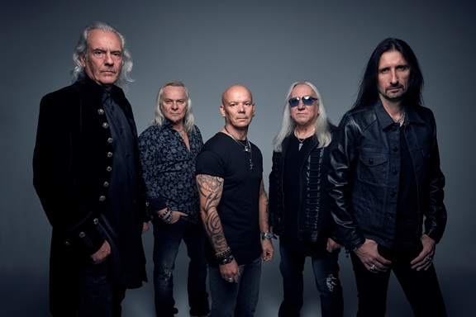
(Photo credit: Richard Stow)

In celebration of the release of their 25th studio album, Living the Dream, classic rock icons URIAH HEEP will embark on a UK tour in late 2018. Kicking off on December 12th in Manchester, the trek will run through December 16th in Hull. The current itinerary can be seen below.

Phil Lanzon comments, “Hey! It’s time to return to our own backyard where it all started. I’m so looking forward to this mini UK tour. Great venues, great people, and it’ll be even ‘greater’ to be back home on familiar territory. Rock it up.”

Vocalist Bernie Shaw continues,”In true Heep fashion the band will be out on tour promoting our newest album Living the Dream released on Sept 14. Our 25th studio album promises to bring some new power and melody to the live shows and we can’t wait to play to our home crowds in the UK this December. 2018-2019 will be a very busy time for the band as we plan a full world tour. I’m sure the fans will love the raw power and traditional Heep musical trademarks that have made the band last so many years. See you out on the road!

Founding member and lead guitarist Mick Box adds, “There is a full European tour booked in support of our new album ‘Living The Dream,’ including some exciting shows in the UK in December. The Heep Rock n’ Roll Circus just keeps on rolling, and long may it last. ‘Appy days!

In addition to the tour announcement, the band are proud to announce that the official release date of Living the Dream will be September 14th on Frontiers Music Srl. This forthcoming studio offering will be the 25th in their storied career. The band have a Pledge Music campaign running in conjunction with this release. Fans who contribute will have access to exclusive behind the scenes footage from the recording sessions as well as other perks such as playing with the band during a soundcheck, a signed copy of the album, and much more! Fans can participate at THIS LOCATION.

Mick Box explains, “The mighty Uriah Heep are excited to announce the release of their new album on the 14th September 2018 called ‘Living The Dream.’ The producer for this project was famed producer Jay Ruston, and this will be released on Frontiers Records. The new album rocks and thanks to our fans and your continued support, we are still Living that Dream. ‘Appy days!”

Bernie Shaw adds, “Jay Ruston’s production has brought the power from our live shows onto the record. A now invaluable member of the “Heep” family.
Can’t wait to play these songs live!”

URIAH HEEP 2018 TOUR DATES:
December 12th: Manchester @ The Ritz
December 13th: Glasgow @ ABC
December 14th: London @ Shepherds Bush Empire
December 15th: Nottingham @ Rock City
December 16th: Hull @ City Hall

ABOUT URIAH HEEP:
URIAH HEEP debuted in 1970 with the release of one of hard rock’s milestones, “Very 'eavy... Very 'umble” and have since sold in excess of 40 million albums worldwide. They constantly tour the world, playing up to 125 shows a year to 500,000+ fans. The band’s live set features the classic tracks from the '70s and is a musical journey from the band's beginnings to the present day.

Along with Led Zeppelin, Black Sabbath and Deep Purple, Uriah Heep helped invent a decorative and uniquely British form of heavy metal with their debut album, Very ‘Eavy, Very ‘Umble, offered as a self-titled on American shores, but whatever the titling, historically massive in the invention of a music format that would rule the ‘70s and only intensify in the ‘80s.

Uriah Heep have been responsible for the most elevated and intelligent use of vocals in a heavy metal context amongst the major bands inventing the genre in the 1970s. It is for this reason Heep were coined the Beach Boys of Heavy Metal, and their influence is there for all to see in other bands including ‘Queen.’ They were also one of the forerunners of using the Hammond organ along with Micks signature wah wah guitar and this became the template for their sound.

Success has followed the forging of such an audacious formula. Across 25 studio albums, along with myriad live releases and compilations, Uriah Heep have managed to sell 40 million records worldwide, four million of those in the US. Impressive American numbers, but that leaves 36 million records to be sold in the rest of the world, underscoring the fact that Uriah Heep have become, through their relentless dedication to touring, a truly global band, with particular success in Germany, Scandinavia, Japan, Eastern Europe and Russia, where they were the first Western rock band to play live in Moscow in December 1987 to 180,000 people.
Through their success as Rock n’ Roll pioneers this enabled other bands to follow in their wake and Russia is now part of every bands touring schedule.

URIAH HEEP is:
Mick Box: Guitars, Vocals
Phil Lanzon: Keyboards, Vocals
Bernie Shaw: Lead Vocals
Russell Gilbrook: Drums, Vocals
Dave Rimmer: Bass, Vocals

For More Info Visit:
www.uriah-heep.com
www.facebook.com/uriahheepofficial/

